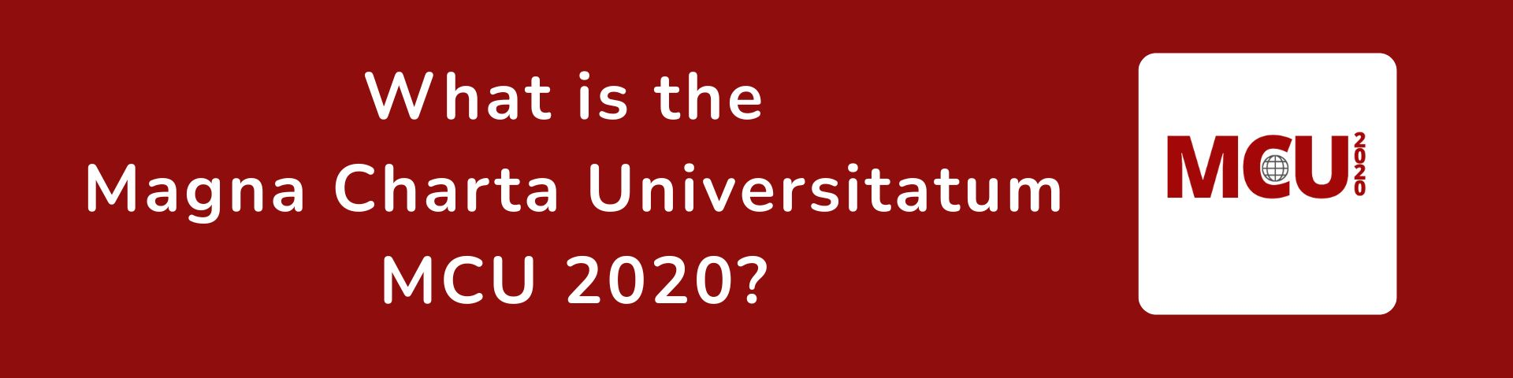

The original Magna Charta Universitatum (MCU) was first signed by 388 universities from around the world in 1988 on the 900th anniversary of the founding of the University of Bologna. The document contained fundamental principles of higher education including academic freedom and institutional autonomy.
Its purpose was to guide universities in achieving good governance and self-understanding in the future.
Since then, universities and the environments in which they operate have changed greatly. In the context of these changes, a multi-national group was formed to review the Magna Charta Universitatum which consulted globally. The outcome of this collective effort was a revised MCU which was adopted by the Governing Council of the Magna Charta Observatory (MCO) in July 2020. The document can be read HERE
The new MCU is a document for the higher education sector which was prepared by the sector. While preserving the essence of the original foundational document, the revised MCU strives to be responsive to and resonate with contemporary challenges and concerns. Its tone recognises that the pursuit of the fundamental values has worth along with their actual attainment, which, in practice, is a constant quest. Moreover, it recognises the more global nature of what universities do and the wider range of local responsibilities which they have in serving local communities. To date, nearly 1000 universities from 94 countries have signed either one or other version of the MCU.

By signing the Magna Charta Universitatum universities demonstrate their commitment to the principles, values and responsibilities set out in the document by making a clear statement to all, locally, nationally and internationally, that they:
      - Operate autonomously, free from all political influence and economic interests;
      - Uphold, promote and protect academic values and freedom responsibly;
      - Ensure that teaching and research are inseparable and that students are encouraged to be fully engaged;
      - Are responsive, responsible and reliable partners for serving society, businesses and other stakeholders;
      - Are proactive participants in addressing global and societal challenges and concerns and preparing students for the future;
      - Provide educational services and create public goods through scientific and social activity;
      - Engage with students effectively enabling them to become responsible democratic citizens.
They thereby collectively strengthen the role of universities in promoting health, prosperity and the common good around the world.
By communicating their commitment internally, signatory universities help to create an environment conducive to free and independent thinking, fostering intellectual development and innovation within the university that engages and motivates staff and students.
The public commitment to the principles, values and responsibilities set out in the MCU enhances the reputation of the university locally, nationally and internationally.

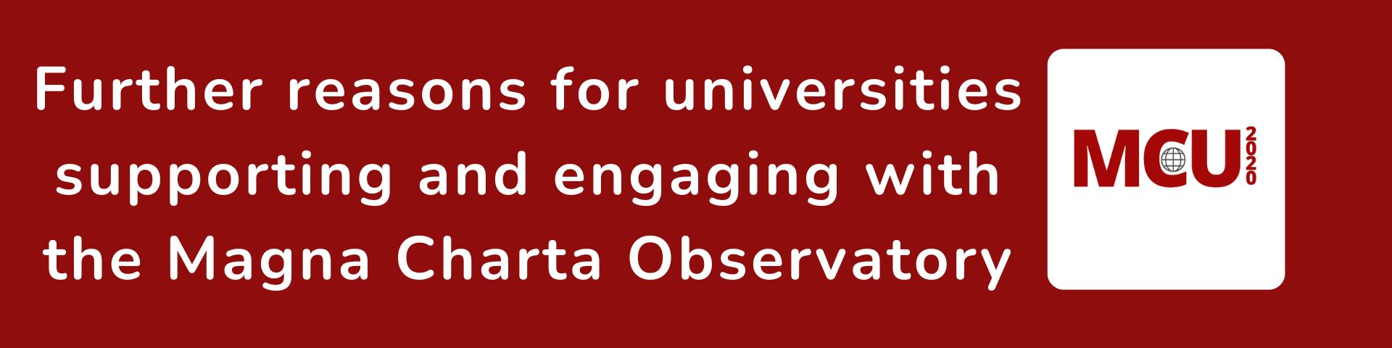
The body responsible for the Magna Charta Universitatum
The MCO is a global organisation that speaks for universities as a whole and particularly for the signatories of the MCU on matters of fundamental values - especially when there are attempts to erode these or restrict their operation. It advises and supports universities in times of challenge and contributes to the development of academic freedom in practice.

The MCU is used globally by universities and groups within the higher education sector as a reference document for enabling the fundamental principles to be to the fore in legislation and operational procedures. It is kept under review by the MCO.

MCO Network and resources

The MCO network facilitates collaboration, partnerships, and exchanges of knowledge, ideas, and best practices among member universities. By participating in the MCO network, universities can enhance their academic programmes, expand their international reach, and develop a more diverse and inclusive learning environment.
The website and repository of the MCO provide a rich source of materials for scholars of integral elements of the MCU.

The MCO organises webinars, conferences and workshops globally and regionally with leading global thinkers and practitioners that its signatories find helpful for achieving their mission.

MCO conferences provide a forum in which research and international partnership scan be formed by universities sharing the same values. These can be developed through staff and student mobility, joint projects, research, funding applications and events.
The Living Values
The MCO is the only global organisation that articulates the living values of universities and has developed a methodology to enable universities to review their values and ensure that they have maximum impact in practice.
The Responsive and Responsible University
The MCO promotes research into how signatory universities are serving society responsibly and responsively, the findings of which are designed to be mutually beneficial and available to enable all universities to better serve society.
Through its collaboration with global and regional student organizations, the MCO offers materials and training support that adopt a values-based approach. These resources aim to empower students to participate actively in the democratic and societal mission of universities, with a particular focus on global citizenship.
MCO Support and Assistance
In times and places of conflict the MCO community provides practical support to enable universities in the countries adversely affected to continue to serve their society.
The MCO works closely with UN recognised global and regional higher education bodies and sector groups, including student organisations to raise awareness of, and give greater effect to, fundamental principles and their implications and develop the understanding of values.



“Education and formation of the nation's intellectual elite is the engine of sustainable society development, guarantee of democratic transformations and national security, a platform for asserting the rights and freedoms of every citizen.
Any modern university should create public good, protect the institutions of childhood, family, and society now and in the future, and contribute to the creation of a mutual educational and scientific space that unites the countries of the civilized world. Education and science should not have borders and should be aimed at creating a multi-cultural environment respecting diversity.The Magna Charta Universitatum allows us to do this together.”

Professor Roman Gryniuk
Rector of Vasyl’ Stus Donetsk National University, Ukraine, March 2023.

"We can change the world for the better if we stand together."

Professor Hanne Solheim Hansen, Rector of Nord University, Norway.
MCO Anniversary signing ceremony, Bologna, September 2022.

By signing the MCU, universities reaffirm their dedication to ethical conduct, the pursuit of knowledge for the betterment of society, and the advancement of sustainable development. This commitment can attract socially conscious students, faculty, and staff who align with the university's values. It also provides a framework for universities to engage in community outreach, address societal challenges, and contribute to the development of their local and global communities. This commitment can enhance the reputation of the university both nationally and internationally indicating that the university is keen on basic principles.”

Professor Marcel Knobel
12th Rector of the University of Campinas (Unicamp), Brazil, April 2023

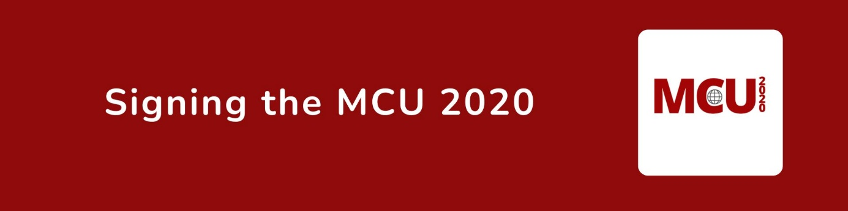
If your university believes in and endeavours to operate in accordance with the principles, values and responsibilities set out in the MCU 2020 and wants to benefit from being part of the MCO community, please CLICK HERE to apply to sign.
There is no fee for signing the MCU 2020 and no annual subscription.
The MCO is a not-for-profit ‘third sector’ organisation registered in Italy. It is funded by a grant from the University of Bologna and donations from signatories. The Observatory is governed by a Governing Council comprising nominees from the University of Bologna, European University Association and a majority of appointed members from universities and student associations around the world who are appointed after a global application and nominations process.
For further information please email magnacharta@unibo.it or go to www.magna-charta.org

Magna Charta Observatory
Via Zamboni, 25 - 40126 Bologna, Italy
magnacharta@unibo.it
+39.051 2098709
www.magna-charta.org

